Week 4 - Sensing and Events

Challenge 1: Cat Bat Fish Game!

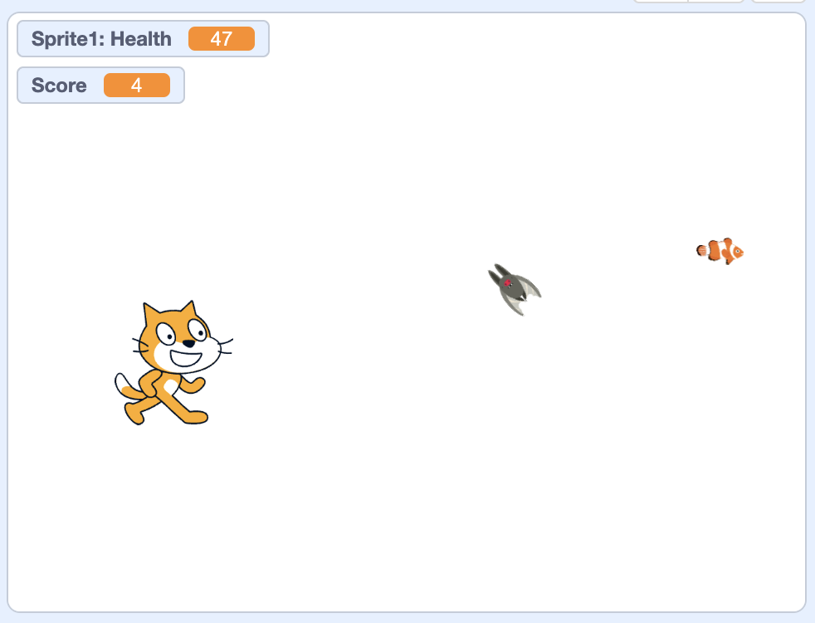

When Flag Clicked
- Cat always starts in the same place
- Cat moves when user presses arrow keys (or WASD if you insist)
- Cat cannot go off the screen
- Bat starts at a random position and moves at a 45 degree angle a little bit faster than the cat can move
- When the bat hits the edge of the screen, it “bounces” and keeps moving
- When the bat hits the cat, the cat loses health
- Bat should “flap” when it moves so it looks like it’s flying (like a bat–so the wings should beat really fast)
- When the cat’s health goes to zero, the game is over
- The fish starts at a random position
- When the cat “gets” the fish (i.e., touches it),
  - the score goes up by one
  - The fish disappears and re-appears at a random position on the field

Some useful things that might help you with this project:

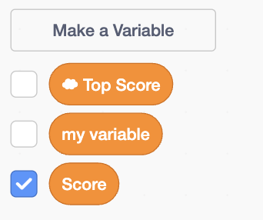 | You can make variables to keep track of things like scores and health. You’ve used a variable before: 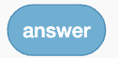--this just allows you to make your own. If you tick the checkmark it will appear within the game.  You can make a variable “for all sprites” (a “global” variable) or “for this sprite” (a “local” variable).
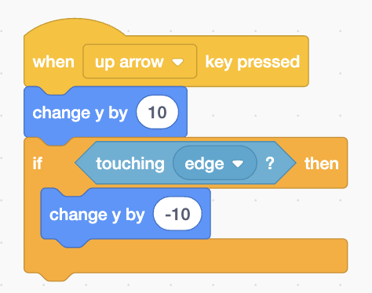 | You can use keyboard events (e.g., when a particular key is pressed) to make code run. This code snippet makes the sprite move up when the up arrow is pressed.  This code also uses a “sensing” block (light blue), which is a kind of block that you can use to check for particular conditions within the game like when things are touching other things.
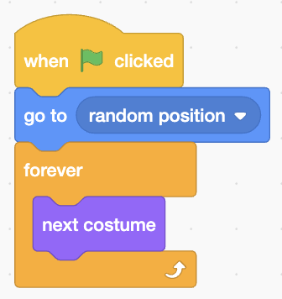 | Have a sprite change costumes really quickly–useful for animation (e.g., a bat flying)
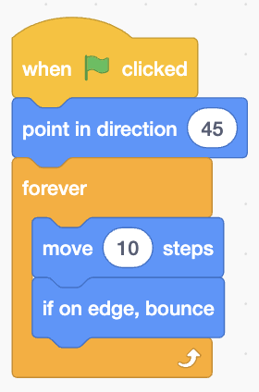 | Make a sprite move forever and bounce when it hits the edge
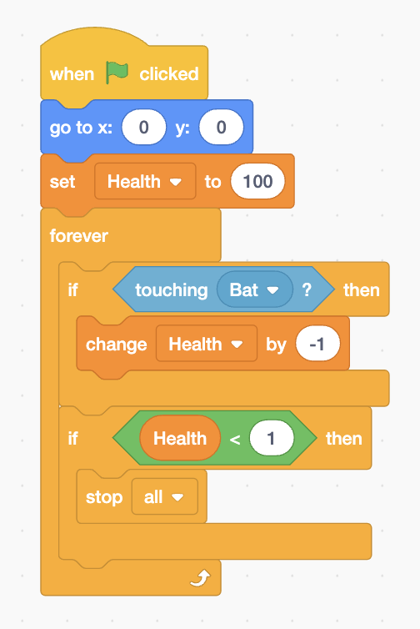 | What does this code do?
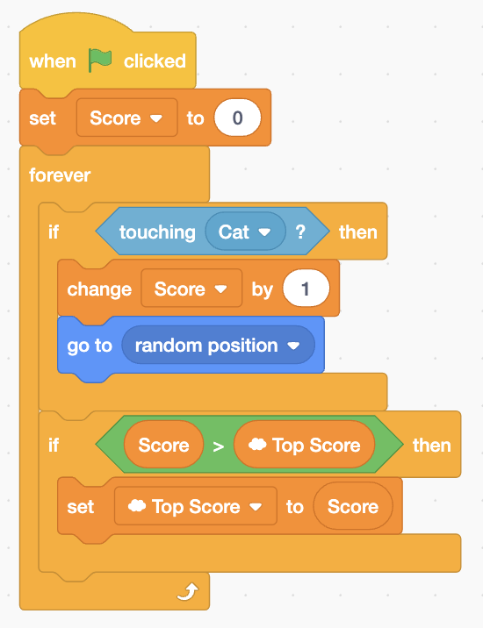 | What about this code?

Challenge 2: Crab Catch 3000
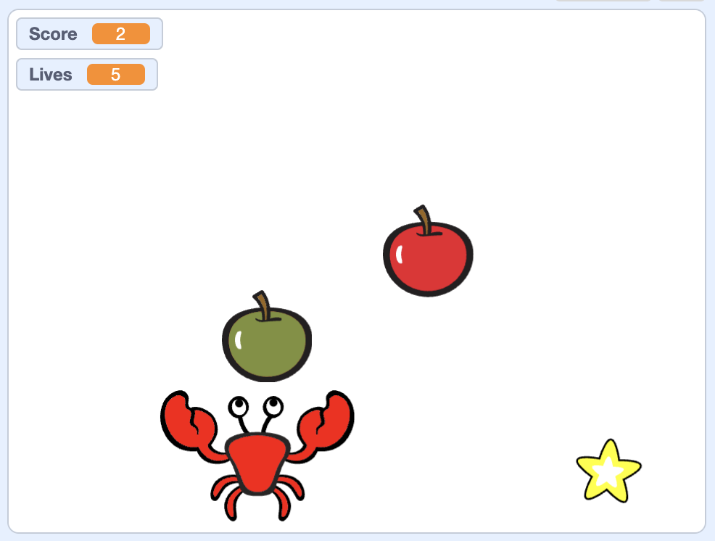

This game uses basically the same concepts as the first game, but is maybe slightly more challenging.

- The crab stays at the bottom of the screen and only moves right and left. It does not move off the screen.
- Stars and both kinds of apples fall from the top of the screen. They start at random positions along the top and fall straight down.
- The red apples fall slowest, green apples a bit faster, and stars fastest of all.
- Red apples fall continuously–there is always one on the screen. As soon as one is caught by the crab or hits the bottom of the screen a new one starts to fall from the top of the screen.
- Green apples fall continuously, but with a pause. When a green apple is caught or reaches the bottom there is a 1-5 second pause before the next green apple starts falling.
- Stars fall continuously, but with a pause. When a star is caught or reaches the bottom there is a 3-8 second pause before the next star starts falling.
- Caught red apples increase the score by 1.
- Caught green apples reduce the score by 1.
- Caught stars increase the score by 5.
- Every time a red apple is NOT caught, the player loses one life. When the user has no lives left the game is over.
- When the game starts, the crab is in the middle, there are no falling things (they start falling right after), the score is 0, and the player has 5 lives.

BONUS: Increase the difficulty (e.g., speed and number of apples) when the score reaches certain thresholds like 100, 200, etc.

